**SQL QUERIES for Food&Beverage**

1. Demographic Insights:
2. Who prefers energy drink more? (male/female/non-binary?)

select Gender, count(*) as gender_count

from dim_repondents

group by Gender

order by gender_count desc;

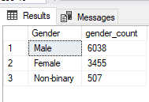

1. Which age group prefers energy drinks more?

select Age, count(*) as Age_preference

from dim_repondents

group by age

order by Age_preference desc;

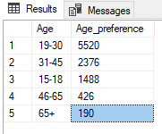

1. Which type of marketing reaches the most Youth (15-30)?

select fact_survey_responses.Marketing_channels, count(*) as marketing_preference from fact_survey_responses

inner join dim_repondents on

fact_survey_responses.Respondent_ID= dim_repondents.Respondent_ID

where dim_repondents.Age = '15-18' or dim_repondents.Age= '19-30'

group by fact_survey_responses.Marketing_channels

order by marketing_preference desc;

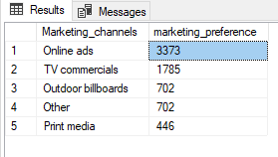

1. Consumer Preferences:
2. What are the preferred ingredients of energy drinks among respondents?

select Ingredients_expected as Ingredients, count(*) as Total_ingredient_preferred

from fact_survey_responses

group by Ingredients_expected

order by Total_ingredient_preferred desc;

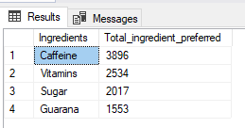

1. What packaging preferences do respondents have for energy drinks?

select Packaging_preference , count(*) as Packaging_preferred

from fact_survey_responses

group by Packaging_preference

order by Packaging_preferred desc;

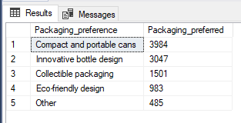

1. Competition Analysis:
2. Who are the current market leaders?

select Current_brands as Brands, count(*) as market_leader

from fact_survey_responses

group by Current_brands

order by market_leader desc;

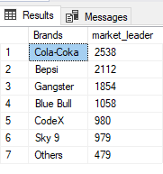

1. What are the primary reasons consumers prefer those brands over ours?

select Reasons_for_choosing_brands as reason_prefer_brands, count(*) as Total_people

from fact_survey_responses

group by Reasons_for_choosing_brands

order by Total_people desc;

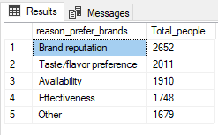

1. Marketing Channels and Brand Awareness:
2. Which marketing channel can be used to reach more customers?

select Marketing_channels , count(*) as prefer_channel

from fact_survey_responses

group by Marketing_channels

order by prefer_channel desc;

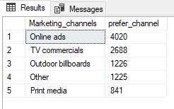

1. How effective are different marketing strategies and channels in reaching our customers?

select Brand_perception , count(*) as brand_response

from fact_survey_responses

group by Brand_perception

order by brand_response desc;

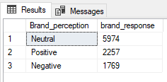

1. Brand Penetration:
2. What do people think about our brand? (overall rating)

select General_perception , count(*) as Brand_rating

from fact_survey_responses

group by General_perception

order by Brand_rating desc;

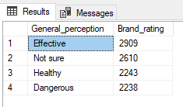

1. Which cities do we need to focus more on?

select dim_cities.City, count(*) as response_count

from dim_cities

inner join dim_repondents on

dim_cities.City_ID = dim_repondents.City_ID

group by dim_cities.City

order by response_count;

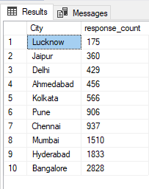

1. Purchase Behavior:
2. Where do respondents prefer to purchase energy drinks?

select Purchase_location, count(*) as count_of_location_preference

from fact_survey_responses

group by Purchase_location

order by count_of_location_preference desc;

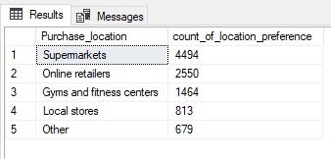

1. What are the typical consumption situations for energy drinks among respondents?

select Consume_reason, count(*) as count_of_consuption

from fact_survey_responses

group by Consume_reason

order by count_of_consuption desc;

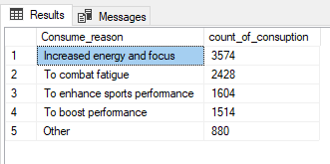

1. What factors influence respondents' purchase decisions, such as price range and limited edition packaging?

select Limited_edition_packaging , count(*) as answer

from fact_survey_responses

group by Limited_edition_packaging

order by answer desc;

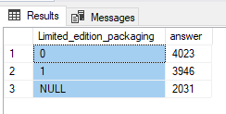

select Price_range, count(*) as price_preferred

from fact_survey_responses

group by Price_range

order by price_preferred desc;

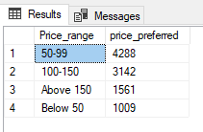

1. Product Development
2. Which area of business should we focus more on our product development? (Branding/taste/availability)

select Reasons_for_choosing_brands, count(*) as reasons

from fact_survey_responses

group by Reasons_for_choosing_brands

order by reasons desc;

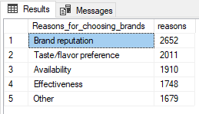

Secondary Insights

1. What immediate improvements can we bring to the product?

select Improvements_desired, count(*) as desire_count

from fact_survey_responses

group by Improvements_desired

order by desire_count desc;

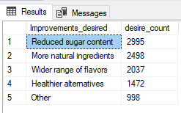

1. What should be the ideal price of our product?

select Price_range , count(*) as prefer_price_count

from fact_survey_responses

group by Price_range

order by prefer_price_count desc;

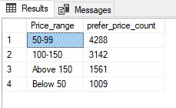

1. What are the reasons for preventing our brand?

select Reasons_preventing_trying , count(*) as reason_count

from fact_survey_responses

group by Reasons_preventing_trying

order by reason_count desc;

